2nd Grade News
March 2019
School to Home Connection:
Second Grade visited the Science Lab last week to learn about the phases of the moon with Mr. John. Students used Oreos to create a model of the 8 different moon phases.
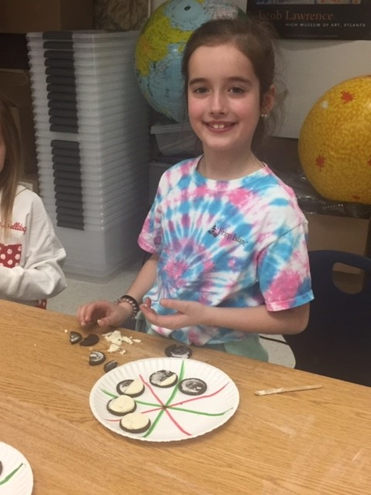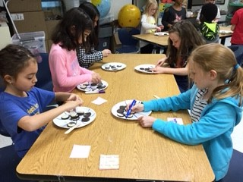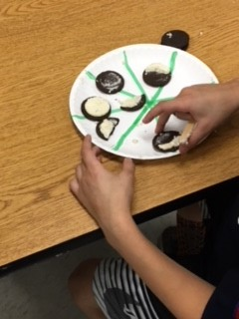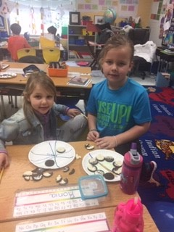

Uruhu Dancers

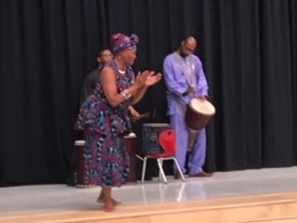
All of the students enjoyed a special performance by the Uruhu Dancers. They are an Atlanta based organization with a goal to develop and educate the community through African culture, dance, music and song.
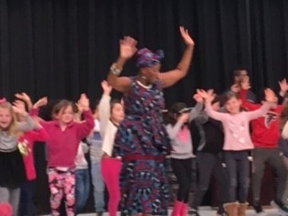
Students joined in the singing and dancing.

Important dates

3/8 school in session for students
3/11 no school-students
3/15 end of 3rd quarter
3/21 Fernbank field trip
3/21 report cards come home
3/23 HFE Parent party
3/26 College pride day

Standards for March
Inquiry into Math- 2.2 Group
- Add up to four two-digit numbers using strategies based on place value and properties of operations.
- Add and subtract within 1000, using concrete models, drawings and various strategies.
- Mentally add 10 or 100 to a given number 100-900, and mentally subtract 10 or 100 from a given number 100-900.
- Explain why addition and subtraction strategies work, using place value and the properties of operations.
- Solve word problems involving dollar bills, quarters, dimes, nickels, and pennies, using $ and ¢ symbols appropriately.

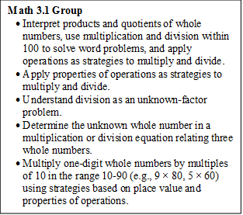
Math 3.2 Group
- Understand that shapes in different categories (e.g., rhombuses, rectangles, and others) may share attributes (e.g., having four sides), and that the shared attributes can define a larger category (e.g., quadrilaterals).
- Partition shapes into parts with equal areas. Express the area of each part as a unit fraction of the whole.
- Draw a scaled picture graph and a scaled bar graph to represent a data set with several categories. Solve one- and two-step problems.
- Generate measurement data by measuring lengths using rulers marked with halves and fourths of an inch. Show the data by making a line plot.
- Relate area to the operations of multiplication and addition.
- Solve real world problems involving perimeters of polygons.

Inquiry into Reading
- Ask and answer such questions as who, what, where, when, why, and how to demonstrate understanding of key details in a text.
- Describe the connection between a series of historical events, scientific ideas or concepts, or steps in technical procedures in a text.
- Identify the main topic of a multi-paragraph text as well as the focus of specific paragraphs within the text.
- Identify specific reasons that support the author’s main topic.
- Compare and contrast 2 texts on the same topic.
Inquiry into Language Arts
- Generalize learned spelling patterns when writing words (e.g., cage → badge; boy → boil).
- Demonstrate command of the conventions of standard English grammar and usage when writing or speaking.
- Consult reference materials, including beginning dictionaries, as needed to check and correct spellings.
- Use glossaries and beginning dictionaries, both print and digital, to determine or clarify the meaning of words and phrases.
Inquiry into Writing
- With guidance and support from adults and peers, focus on a topic and strengthen writing as needed by revising and editing.
- Write informative/explanatory texts in which they introduce a topic, use facts and definitions to develop points, and provide a concluding statement or section.
- With guidance and support from adults, use a variety of digital tools to produce and publish writing, including in collaboration with peers.
Inquiry into Science
- Investigate the properties of matter and changes that occur in objects.
PYP Unit 5: How the World Works Central Idea- Inquirers observe change. The central idea is: Inquirers observe change. The key concepts are change, connection and causation.
Contacts:
Ms. Capers– capersj1@fultonschools.org http://capers2nd.weebly.com
Ms. Garrick– garrick@fultonschools.org http://garrick2nd.weebly.com
Ms. Parks- parksm@fultonschools.org http://parksm2.weebly.com/
Ms. Weber- weberj@fultonschools.org http://weber2nd.weebly.com
Ms. Youel- youel@fultonschools.org http://youelsecond.weebly.com

