2nd Grade News
October 2018
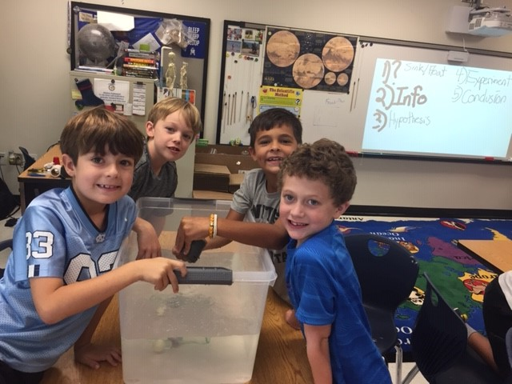

Our students exhibiting two of the attributes of the learner profile, Inquirer and Thinker.
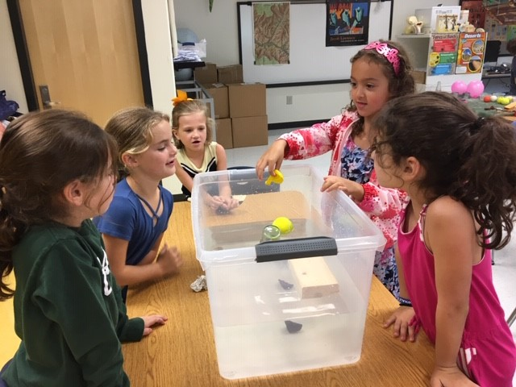
In the Science Lab, Mr. John taught the students the steps of the Scientific Method.
- Ask a question
- Research your topic
- State your hypothesis
- Test your hypothesis
- Analyze your data
- Report your results

Then, the students applied what they had learned with an experiment about sinking and floating objects.
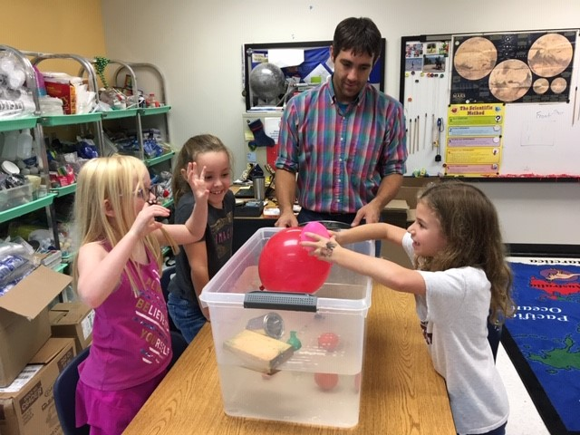

IMPORTANT DATES

10/12 SPIRIT DAY-WEAR YOUR TEAM COLOR
10/18 REPORT CARDS SENT HOME
10/21 AUTUMN ADVENTURE
10/29-11/2 RED RIBBON WEEK
10/31 STORYBOOK CHARACTER DAY

School to Home Connection

By the end of 2nd grade, students are expected to fluently add and subtract numbers within 20. This standard mentions the word fluently when students are adding and subtracting numbers within 20. Fluency means accuracy (correct answer), efficiency (within 4-5 seconds), and flexibility (using strategies such as making 10, breaking apart numbers, using knowledge of fact families and mental math strategies). In the classroom, we support students’ memorization of sums and differences through varied experiences. At home, you can support your child by working with them on the strategies listed above as well as using flashcards or apps like Sushi Math, Reflex Math or Math Academy. For examples of the fluency strategies, follow this link to page 4-5: https://www.georgiastandards.org/Georgia-Standards/Frameworks/Unit-2-2nd-grade-parent-letter.pdf .

Standards for October

Inquiry into Math-2.1 Group Inquiry into Math-2.2 Group
- Fluently add and subtract within 20 using mental strategies.
- Fluently add and subtract within 100 using various strategies.
- Use addition and subtraction within 100 to solve one and two step word problems.
- Partition a rectangle into rows and columns of same-size squares to find the total number of them.
- Partition circles and rectangles into two, three, or four equal shares, describe the shares using the words halves, thirds, half of, a third of, etc., and describe the whole as two halves, three thirds, four fourths.

Inquiry into Math-3.1 Group
- Use multiplication and division within 100 to solve word problems.
- Determine the unknown whole number in a multiplication or division equation relating three whole numbers.
- Understand properties of multiplication and the relationship between multiplication and division.
- Apply properties of operations as strategies to multiply and divide. Multiply one-digit whole numbers by multiples of 10 in the range 10-90. Interpret products of whole numbers. Interpret whole-number quotients of whole numbers.

Inquiry into Reading
- Ask and answer such questions as who, what, where, when, why, and how to demonstrate understanding of key details in a non-fiction text.
- Identify the main topic of a multi-paragraph text as well as the focus of specific paragraphs within the text.
- Know and use various text features (e.g., captions, bold print, subheadings, glossaries, table of contents, photos, diagrams) to locate key facts or information in a text efficiently.
- Describe how reasons support specific points the author makes in a text.
Inquiry into Writing
- Determine the meaning of the new word formed when a known prefix is added to a known word (e.g., happy/unhappy, tell/retell). Use a known root word as a clue to the meaning of an unknown word with the same root (e.g., addition, additional).
- Write informative/explanatory texts in which they introduce a topic, use facts and definitions to develop points, and provide a concluding statement or section.
- Participate in shared research and writing project. With guidance and support from adults and peers, focus on a topic and strengthen writing as needed by revising and editing

Inquiry into Science
- Recognize effects that occur in a specific area caused by weather, plants, animals, and/or people.
- Determine the sequence of the life cycle of common animals in your area: a mammal such as a cat or dog, a bird such as a chicken, an amphibian such as a frog, and an insect such as a butterfly.
- Relate seasonal changes to observations of how a tree changes throughout a school year.
- Investigate the life cycle of a plant by growing a plant from a seed and by recording changes over a period of time.
- Identify fungi (mushroom) as living organisms.
Inquiry into Social Studies
- Locate all the geographic regions of Georgia: Blue Ridge Mountains, Piedmont, Coastal Plain, Valley and Ridge, and Appalachian Plateau.

PYP Unit of Inquiry-Where We Are in Place and Time

The central idea is: Living things and nature cause change.
The key concepts are change, form, connection and some related concepts that we will discuss are environment, geographical changes and transformation.

Contacts:
Ms. Capers- capersj1@fultonschools.org http://capers2nd.weebly.com
Ms. Garrick– garrick@fultonschools.org http://garrick2nd.weebly.com
Ms. Parks: ParksM@fultonschools.org http://parksm2.weebly.com
Ms. Weber- weberj@fultonschools.org http://weber2nd.weebly.com
Ms. Youel- youel@fultonschools.org http://youelsecond.weebly.com

