**Homework- Week of March 12, 2019**

* + **2.2 Math Group**: Please solve the following word problems. Make sure to show all your work.

1. There are 437 girls and 282 boys in the soccer league. How many more girls than boys are there in the league?
2. Coach Lion ordered 522 small jerseys and 199 large jerseys for the league. How many more players wear small jerseys than large ones?

* **3.1 Math Group:**
  + Practice Multiplication Fact Fluency!



Use the array to show how 2x6 can help you solve 2x9.

|  |  |  |  |  |  |  |  |  |
| --- | --- | --- | --- | --- | --- | --- | --- | --- |
|  |  |  |  |  |  |  |  |  |
|  |  |  |  |  |  |  |  |  |

2x9=(____ x ____) + (____ x ____)=

* **3.2 Math Group:** Chloe walks around a short field for exercise. The field is 12 meters long and 9 meters wide. How far does Chloe walk, if walks directly around the field’s perimeter?

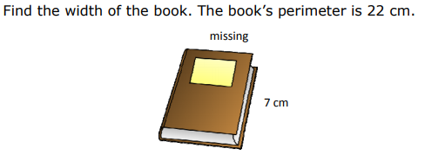

* **International Inquirer:** Students will inquire about nature from their International Day country and can choose from plants (ex: national flower), animals, or national parks.
* Create a poster (no bigger than 9 x 12) and include 5 facts, illustrations, and/or photographs to put on your poster.
  + Make sure your work is neat.
  + Be creative (**be a risk-taker** ☺)

**Capers:** Ethiopia  **Garrick:** Jamaica  **Parks:** Greece **Weber:** Scotland **Youel:** Sweden **\*\*Turn in your posters on Friday March 15, 2019**