- Practice IRead/IReady-reading (only students that have completed IRead should be working on Iready-reading)
2.2 Math-
1) The table below lists the number of people who went to the Georgia Aquarium from June through August.
June | July | August
542 | 489 | 671
a) How many fewer people went to the museum in July than August?

b) How many people went to the aquarium in June and July?

2) Jacob travels 561 miles to visit his cousins. The next day, he travels 100 miles more to Sam’s house. How many miles did Jacob travel in all. Show your work.

3.1 Math Group:
Use the CUBES (circle the numbers, underline the question, box key words, eliminate unwanted information, and solve) strategy to solve the word problem.
a) Solve the following story problem: Luz bought 6 bags of muffins with 3 muffins in each bag. How many muffins does Luz have in all?

b) Jeremy has 21 balls. He puts an equal amount of balls in 7 boxes. How many balls will be in each box?

3.2 Math Group:
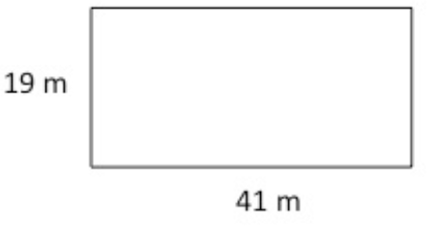
Maggie solved for the perimeter of the rectangle above. Her answer was 799. Is she correct? Why or Why not? Show your reasoning.

