**Homework Week of May 13, 2019**

**Math-**

2.2 Math-

Mariah is baking cookies with her mom. She needs to fit 12 cookies on the baking pan. Draw an array to show how the cookies could be arranged on the baking pan. Write an equation to show how you will reach your total of 12 cookies. Explain how this makes an array.

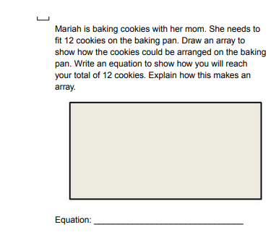

3.1 Math-

Write a word problem where the answer is 72 sq. feet.

Michelle bought a carpet that was 48 sq. feet.  The width was 6 feet, what was the length?

3.2 Math-

Draw a number line to show the elapsed time for each of the problems below.

|  |  |  |
| --- | --- | --- |
| **Start Time** | **End Time** | **Elapsed Time** |
| 2:40 | 4:15 |  |
| 12:35 | 1:50 |  |
| 7:15 | 10:30 |  |
| 3:42 | 5:17 |  |

**Reading-** Read for 20 minutes.

**Social Studies-** Study for the test.